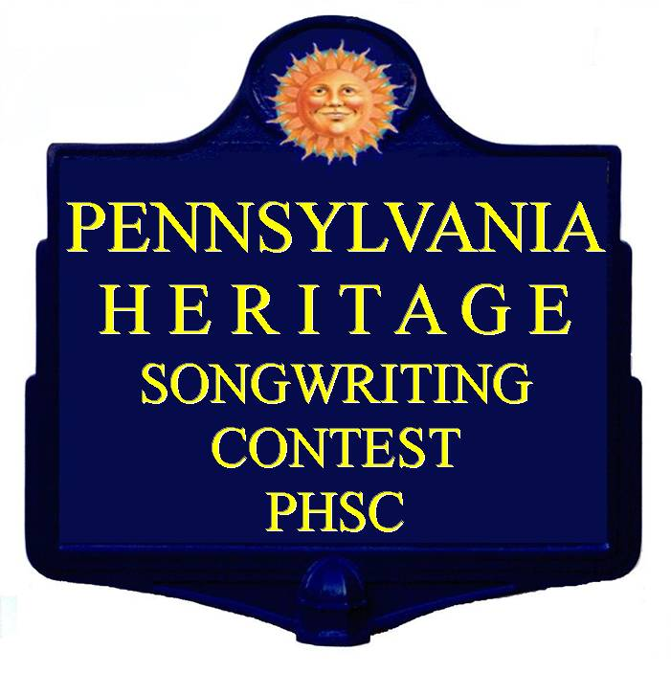

PA Heritage Songwriting Official Contest Rules

Purpose:
The Pennsylvania Heritage Songwriting Contest (PHSC) has been created to celebrate the State of Pennsylvania, its people, places, and history in song. It is intended to provide a venue for amateur songwriters to display their art while fostering appreciation and study of Pennsylvania Heritage.

Theme:
Pennsylvania Heritage: The songs must have a PA namesake, theme or reference.

Finalist Performance Venue:
Approximately 5 PM Saturday at the Smoked Country Jam Bluegrass Festival Main Stage, the third weekend in June at the Quiet Oaks Campground near Cross Fork, PA.
Entry Fee:
$15 per song – Limit two songs per entrant. Fee is non refundable. If payment through PayPal is requested, $0.75 is added to per song entered ($15.75 per song.

Key Contest Dates:
- Entry Deadline: May 15th. Mailed entries must be postmarked by May 15th.
- Winners will be notified by June 1st.

Winner’s Will Receive:
- 1st Place - $100 & one (2) full festival passes
- 2nd Place - $75 & one (1) full festival pass
- 3rd Place – $50 & one (1) full festival pass
- The top three finishers will be invited to perform their winning song beginning at approximately 5 PM Saturday on the main stage at Smoked County Jam
- Finishers will also be eligible to receive donated merchandise.
Recording:
A condition of entering is permitting use of entry recordings or a recording of the SCJ performance to be included on a SCJ Compilation CD, to be sold at SCJ events and on the SCJ website for fundraising (PHSC is a not-for-profit event). Compilation recordings will also be submitted to the Smithsonian Folkways Library to be cataloged.

Eligibility:
The Pennsylvania Heritage Songwriting Contest is intended to be an “Amateur’s event and is not open to “professional” songwriters or those whose primary source of income (50% or more) is derived from songwriting or publishing. Income from performing gigs is not considered songwriting income. Co-writers are subject to the same eligibility requirements as the entrant. SCJ performing artists are eligible to enter PHSC.

PA Heritage Rules Detail

New in 2021 – All entries Digital

- Audio Files, Entry Forms, and Lyrics are to be submitted electronically at music@ecosa.net - please indicate PHSC Entry in the subject line. .mp3 preferred.
- Entry Fee: $15 per song up to two songs ($30). Entrants my request a PayPal invoice for payment. Paper checks or Money Orders are discouraged but will be accepted. Paper payment must be made out to Ecosa and mailed to PHSC c/o ECOSA Music, 30 Pinewood Place, Asheville, NC 28806.
- The entrant may request Payment through an invoice from PayPal at an additional cost of $0.75 per song.
- Don’t Send Bio’s or Press Packages.
- The Pennsylvania Heritage Songwriting Contest is open to any amateur songwriter.
- Each song submitted must be entrant’s original work.
- Contestants cannot be signed to a label or publishing deal.
- A song is defined as a melody with lyrics.
- Contestants must be at least 13 years of age.
- Any contest winner under the legal age of 18 must provide the express written consent of a parent or legal guardian within 48 hours following notification in order to receive prizes and/or promotion through the contest sponsors.
- Entrants retain all publishing rights to their song(s).
- Additions or deletions to these rules may be made at the discretion of Smoked Country Jam, and may be enacted at any time.
- Festival Performers are eligible to enter the competition.
- The place winners will be selected by a panel of judges through a double blind process.
- The top three place winners will be notified by June 1st. Only place winners will be notified. Like us at Facebook https://www.facebook.com/home.php#!/pages/Pennsylvania-Heritage-Songwriters/172643256222742 to see the results.

Or Join us on Facebook: https://www.facebook.com/groups/232795950147539/

- Performance to be solo by composer or composer as singer with only one accompanist.

Evaluation Criteria
- 80% Lyric Composition (includes strength of tie to Pennsylvania, depth, insight, cleverness, beauty...)
- 10% Quality of Vocal Rendering (includes vocal quality, pitch, delivery, etc...)
- 10% Quality of Delivery (instrumental technique, induction, structure, arrangement)

Creation of the PHSC event was inspired by the life and music of Pennsylvanian Craig A. “Bubba” Bowman who was taken from the stage in his prime. Any proceeds from this Non Profit event will be donated to the Craig A. “Bubba” Bowman Scholarship Fund.

Questions and Inquires: email music@ecosa.net with PHSC in the subject line.

Updated for 2021

